

**Implementing CRM for Result tracking of a candidate with**

**internal marks.**

1. **INTRODUCTION** 
   1. Overview

All base data, such as Semester, Candidate, Course, and Lecturer, should be created by the Administrator.The ability of the lecturer to provide internal resultsThe only person who should be able to update Internal Results is Dean, one of the Lecturers.Re-evaluation For all Internal Results, it can be initialised by the Candidate.After the re-evaluation, only the dean can now update the grades..

* 1. Purpose

Implementing CRM for Result tracking of a candidate with internal marks. This will let you know about Result tracking of a candidate with internal marks..

1. **Problem Definition & Design Thinking** 
   1. 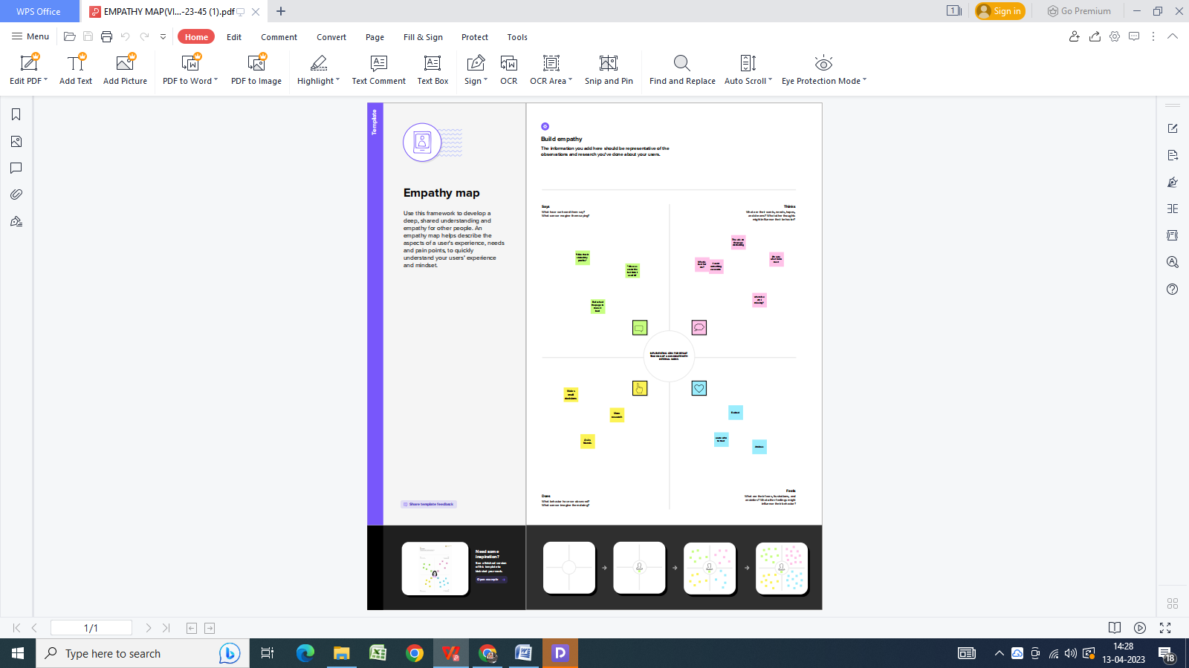
   2. Ideation & Brainstorming Map:

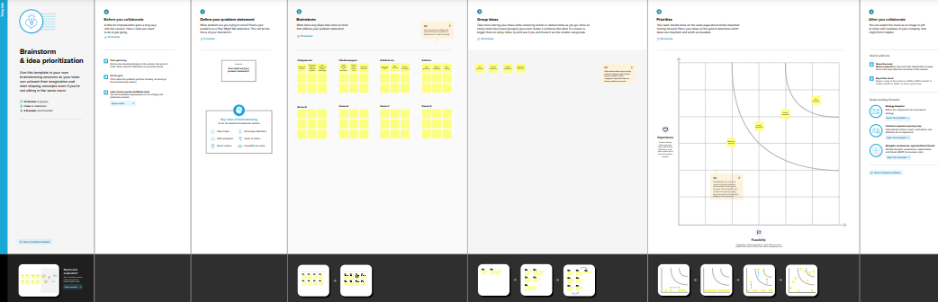

1. **RESULT** 
   1. Data Model:

|  |  |  |
| --- | --- | --- |
| **Object name** | **Fields in the Object** | |
| obj1 | Field label | Data type |
|  |  |  |
| semester | semester | Auto number |
|  |  |  |
|  |  |  |
|  |  |  |
|  |  |  |
|  |  |  |

* 1. Activity & Screenshot

Attach the screenshots of your project activity along with the

description.

1. **Trailhead Profile Public URL**

**Team Lead - https://trailblazer.me/id/vkumar3423**

**Team Member 1 - https://trailblazer.me/id/vvedha5**

**Team Member 2 - https://trailblazer.me/id/saths57**

**Team Member 3 – https://trailblazer.me/id/kathir15**

1. **ADVANTAGES & DISADVANTAGE**

* Cost-cutting measures;
* Improvements in service/product quality;
* Process Improvements for Organization Management;
* Enhanced Customer Loyalty;
* Track and raise the number of potential clients.
* Previous interactions with each student.. ..

1. **APPLICATIONS**

Administrator should be able to create all base data including Semester, Candidate, Course and Lecturer

1. **CONCLUSION**

Lecturer should have the ability to create Internal Results Dean, who is one of the Lecturer, should be the only one with ability to update Internal Results Re-evaluation Can be initialised by Candidate for all Internal Results. Have a multilevel approval process for the re-evaluation of the internal marks, 1st level by lecturer and 2nd level by dean. Now only dean can update the marks after re- evaluation

1. **FUTURE SCOPE**

Dean should be able to see list of Candidates grouped by Marks (Pass / Fail) in each Semester –

should be a VisualForce page. Dean should be able to see average percentage of each Course for a Candidate. Dean should have the ability to view Pass percentage for each Semester.